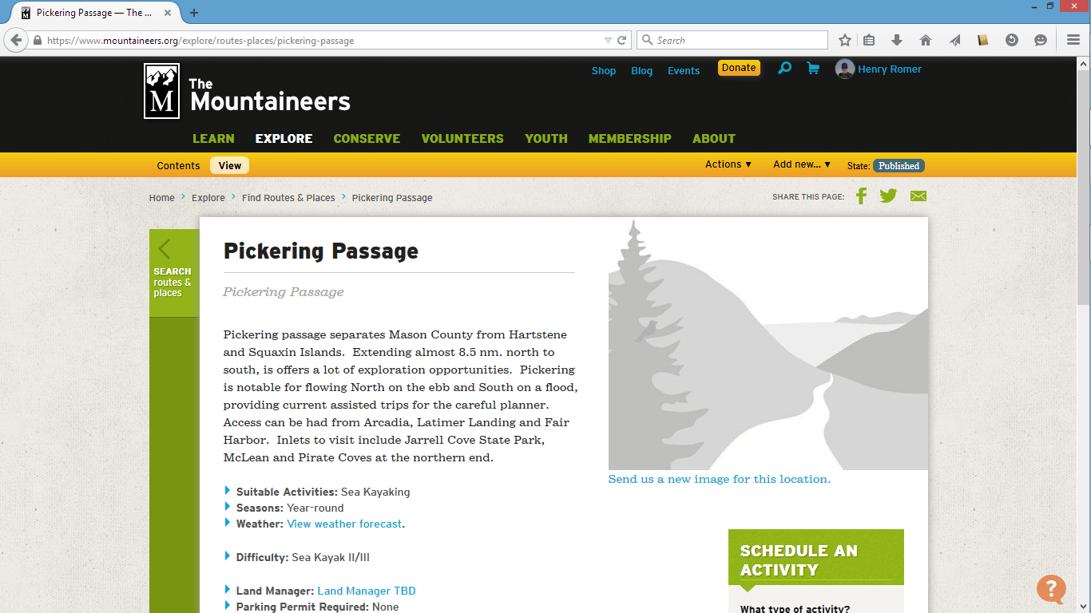

Step 1: Pick a route/place

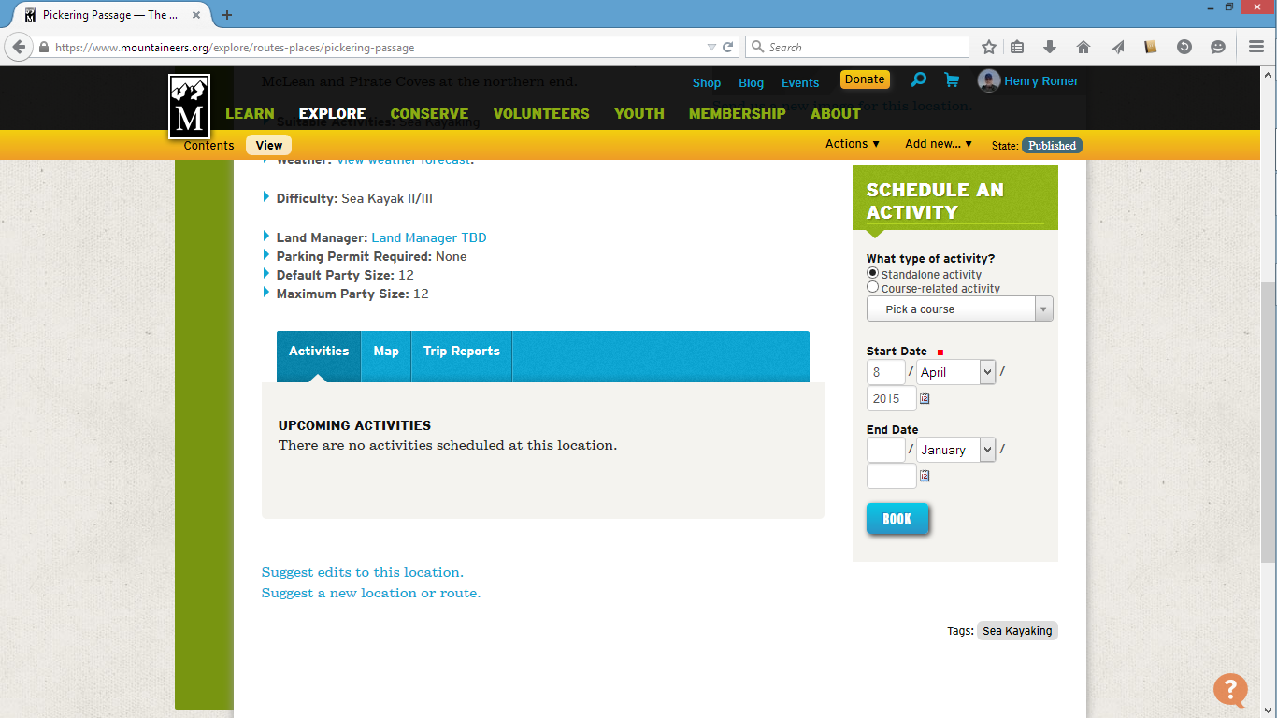

Step 2: Pick a date

27 June

27 June
This will show other activities for this Route/Place
Book

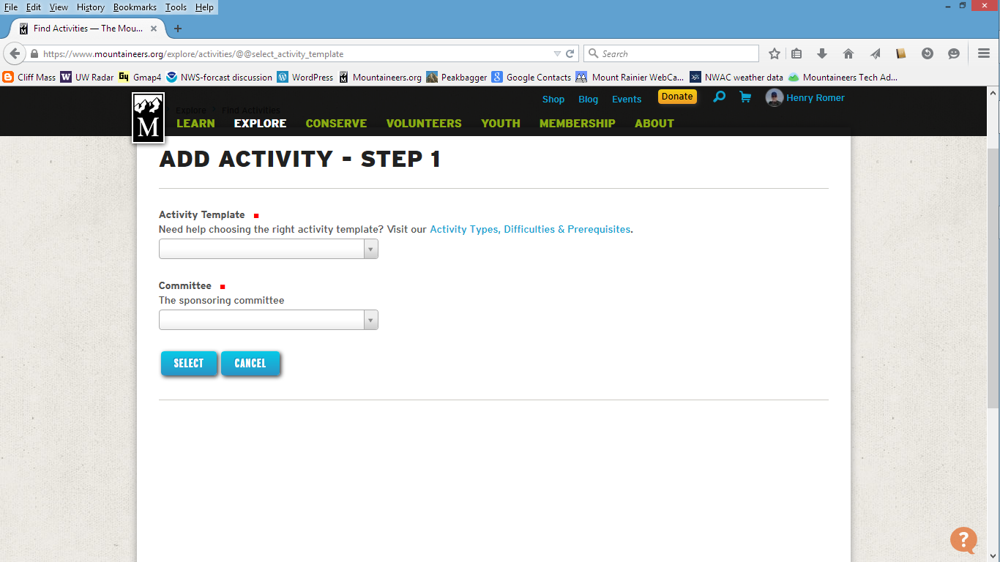

Select “Sea Kayak”

Olympia Sea Kayak Committee

Select to continue

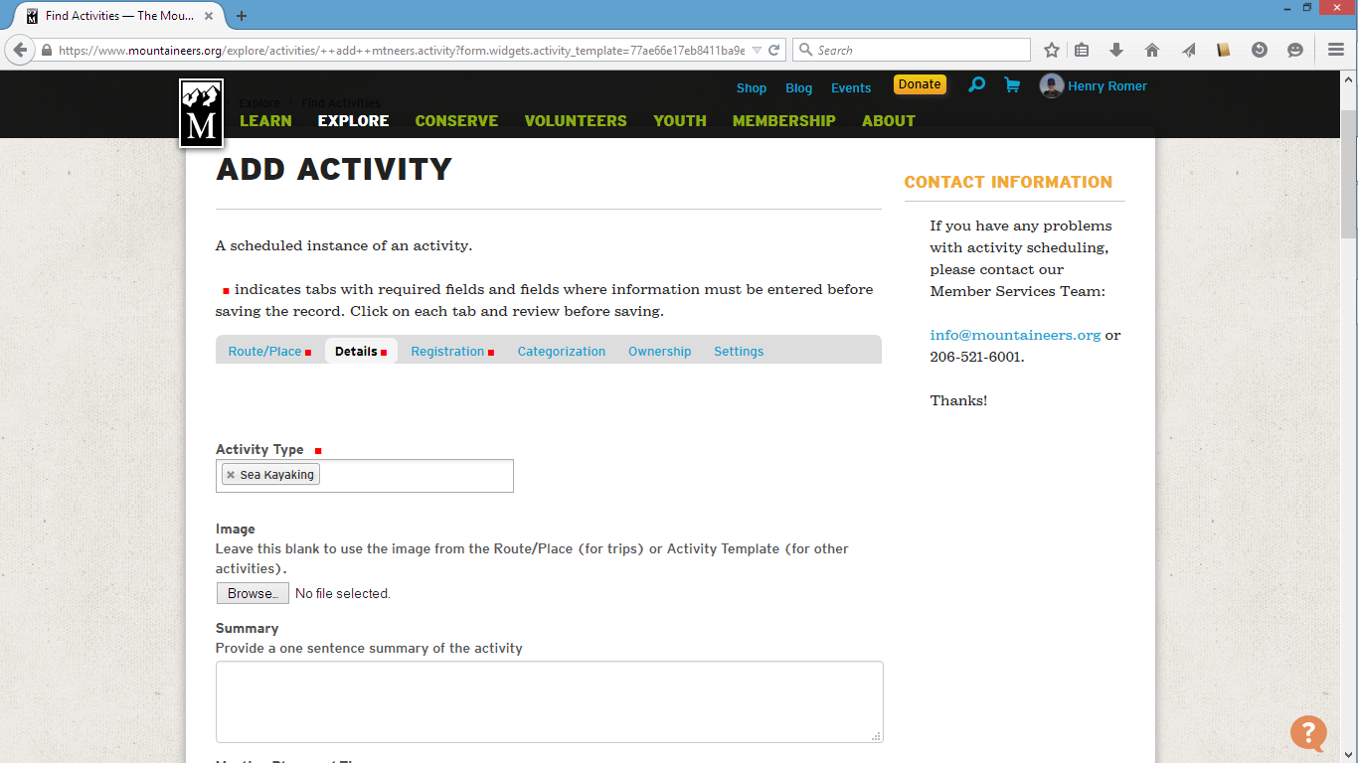

You can import a different picture here

Pickering Passage, SK II, 8 nm
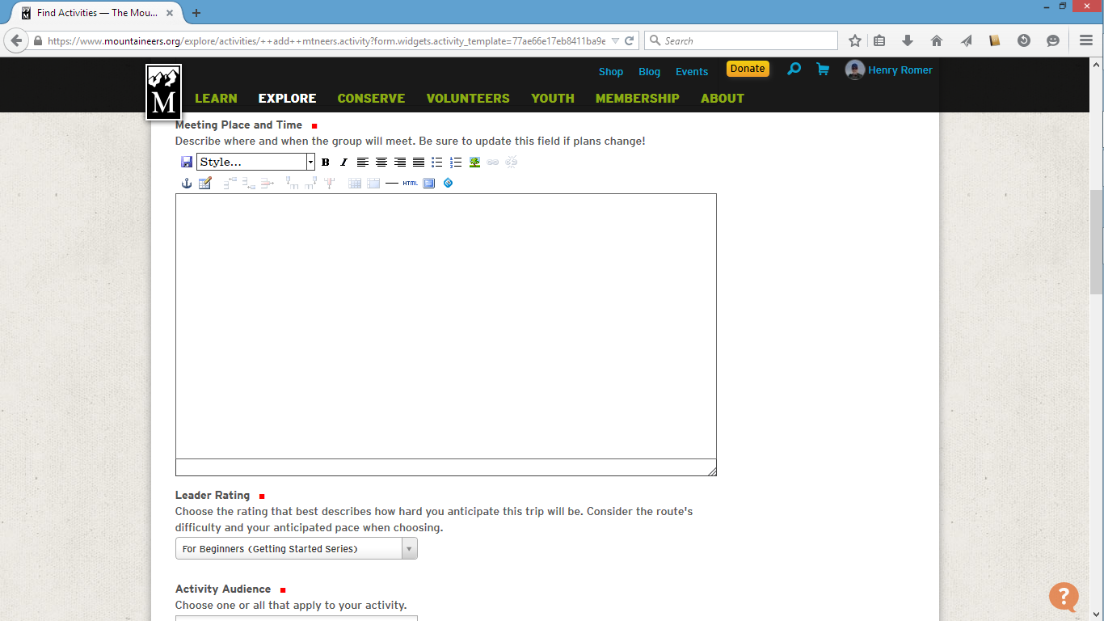

Arcadia Launch Ramp, 9 am

Easy

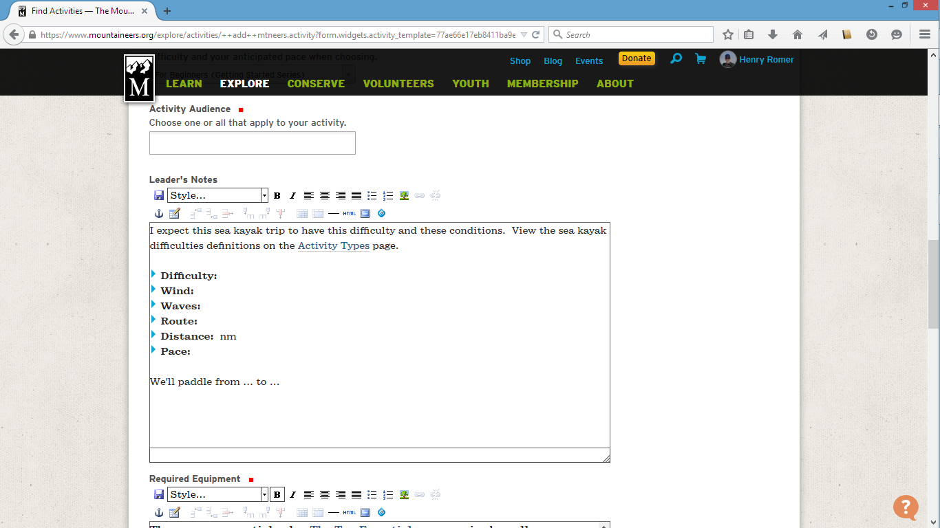

Adults

SK II, 8 nm. We will head north from Arcadia to the
Hartstene Island Bridge and explore lower Pickering
Passage. This is an experience paddle, suitable for
this year’s Basic Class students. Priority will be given
to Olympia students.

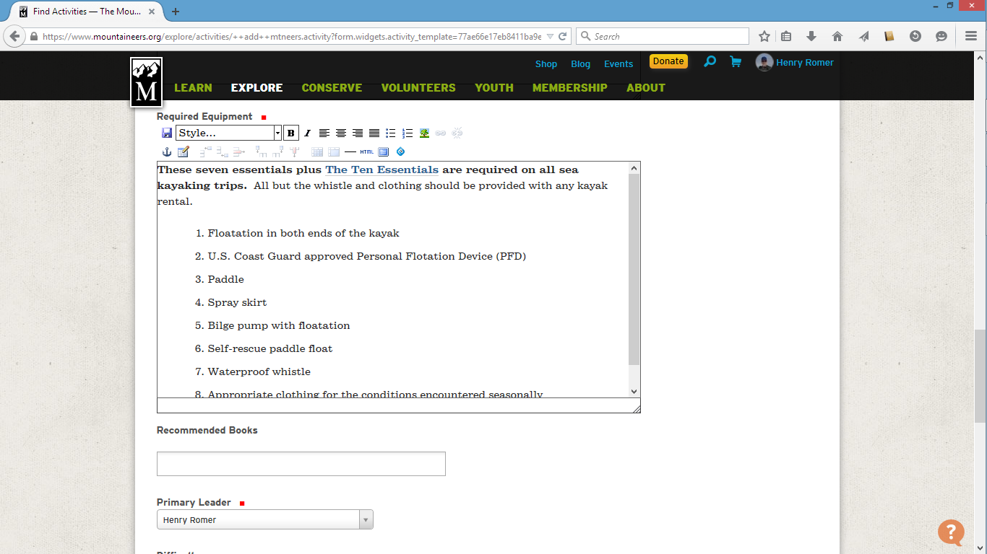

Add anything if desired

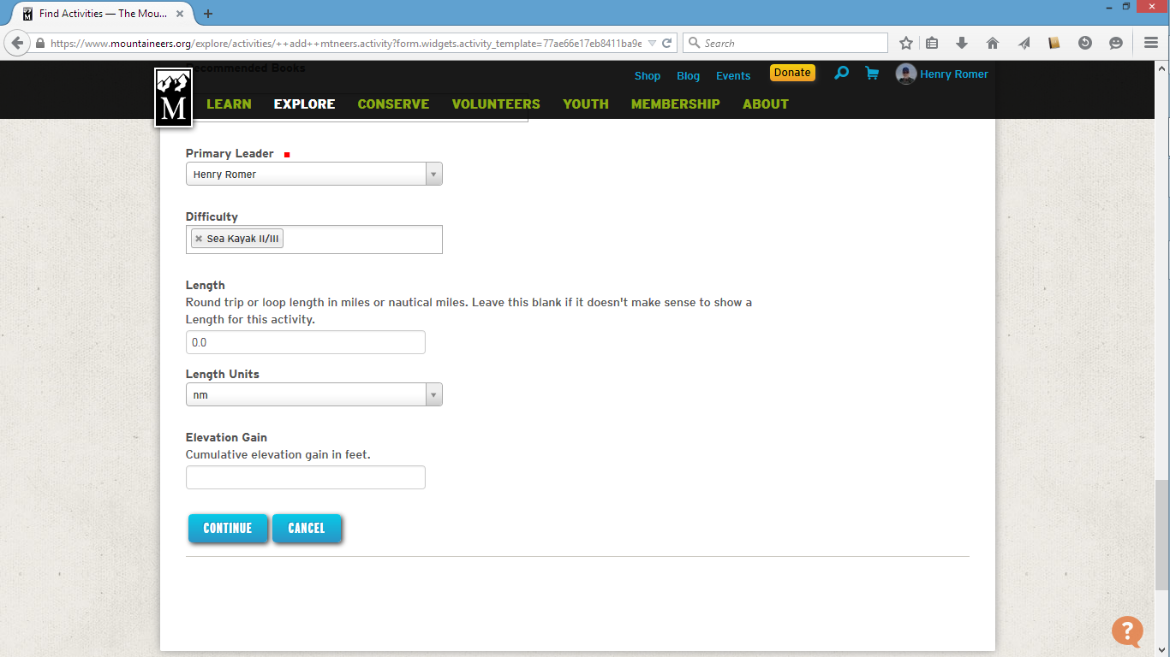

Delete default for this route and select SK II

8.0

Continue to next section

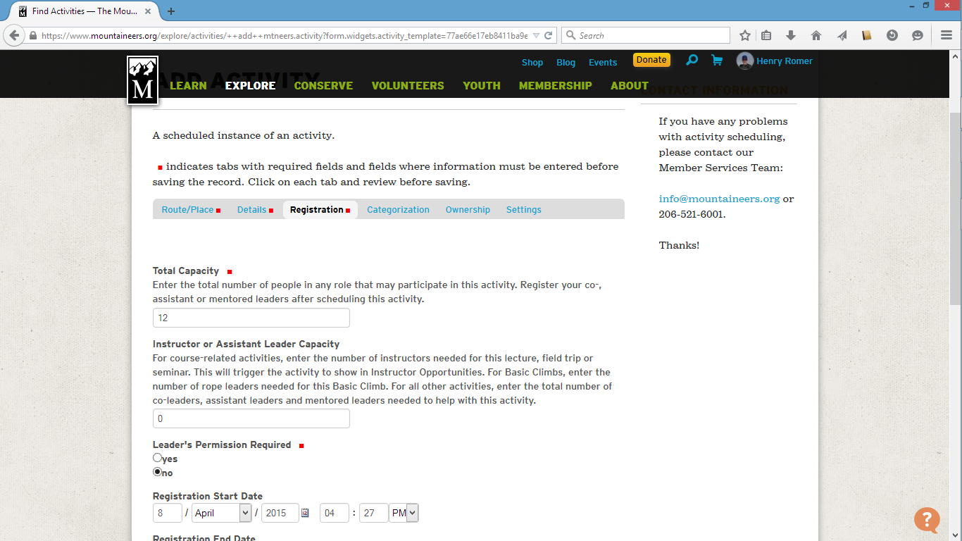

10

Change to “yes”

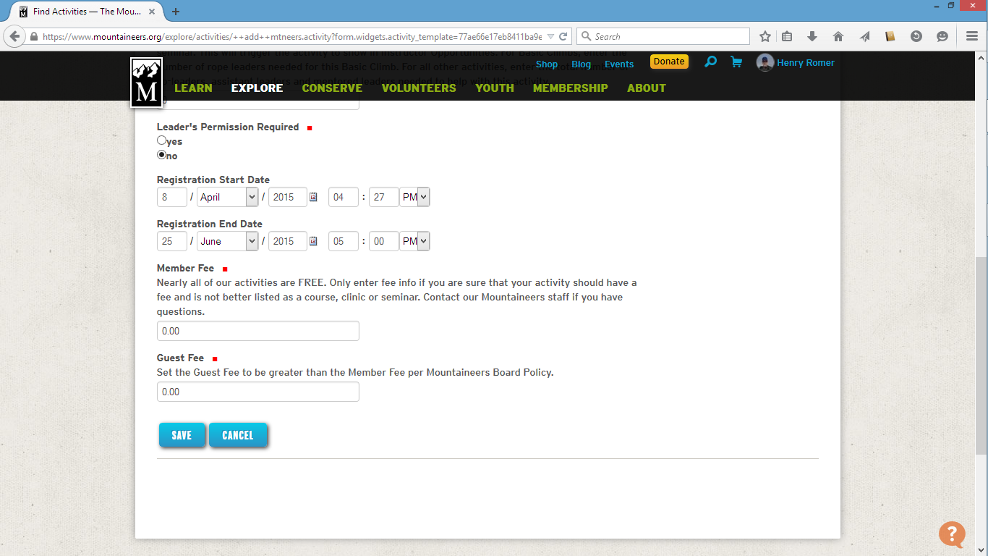

May 6 is day after Lecture 2 for our class
AM is fine here

June 25 PM is the Thursday before the trip

Save will enter the trip into the data base. It will show
When the registration opens.

To make changes to the roster:
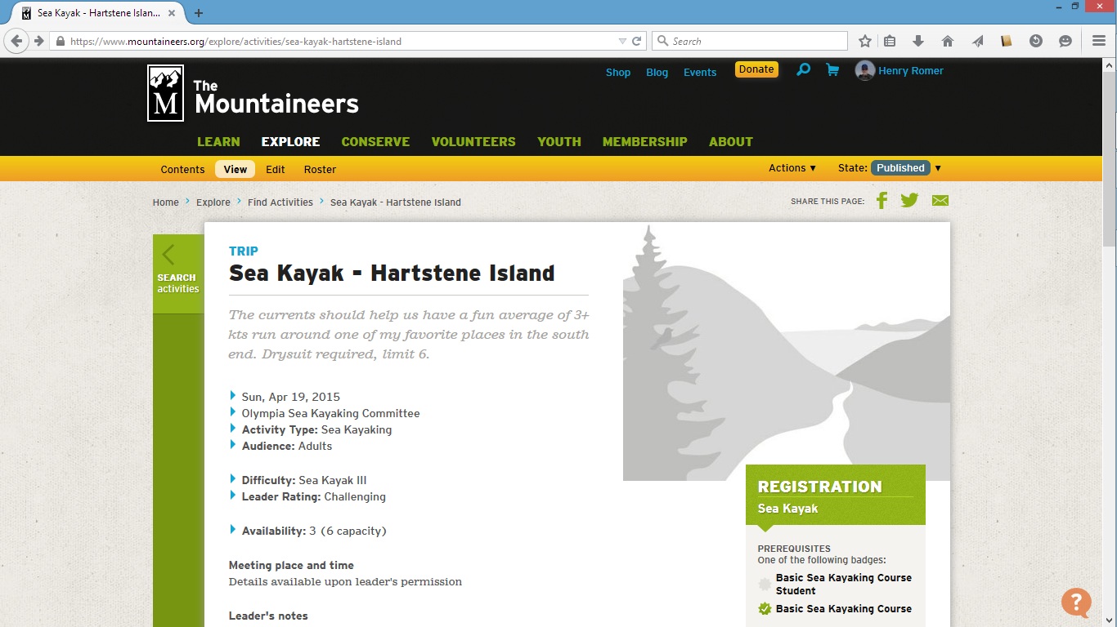

Click here on “Roster”

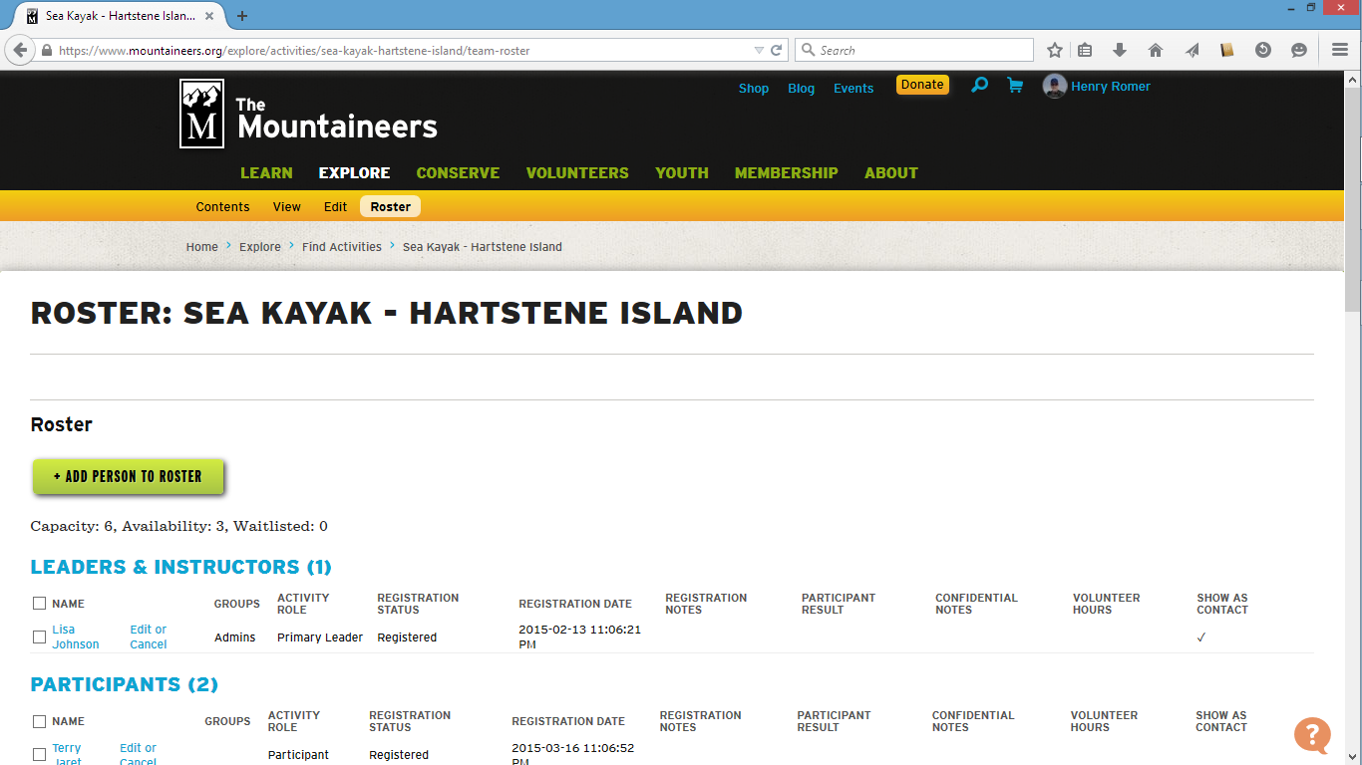

To add a person, click here

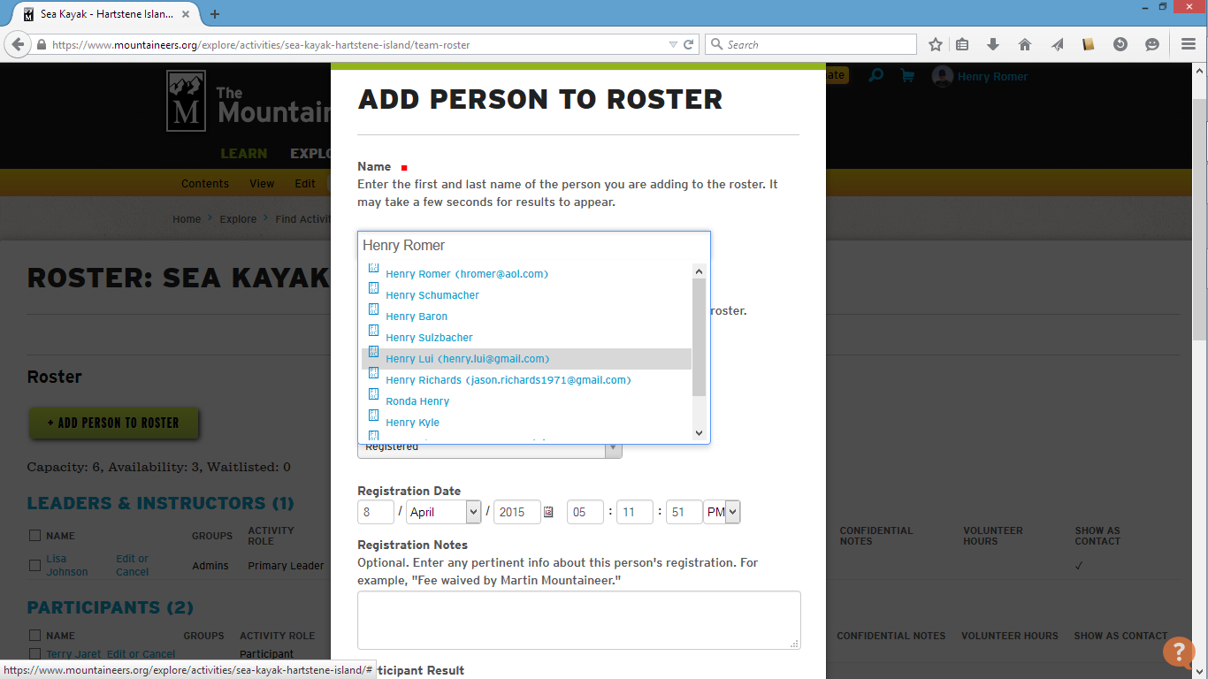

Type the name here

Then pick from the list

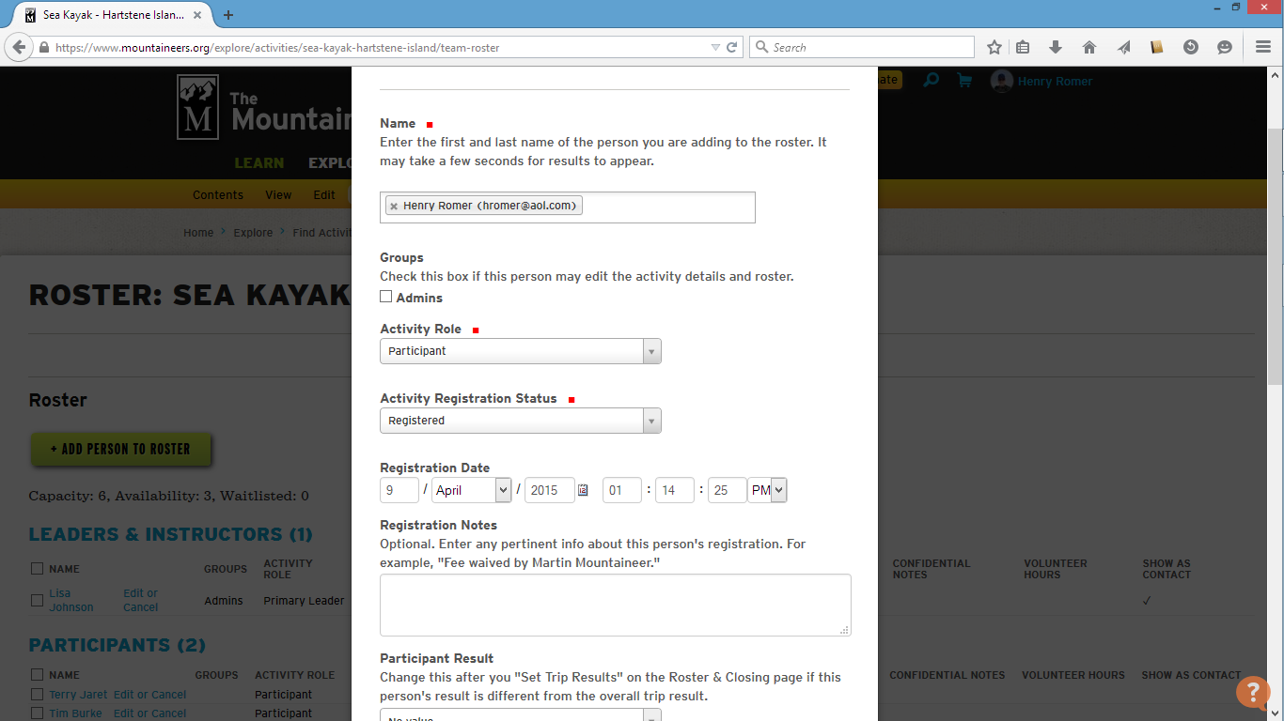

Save and the person is added

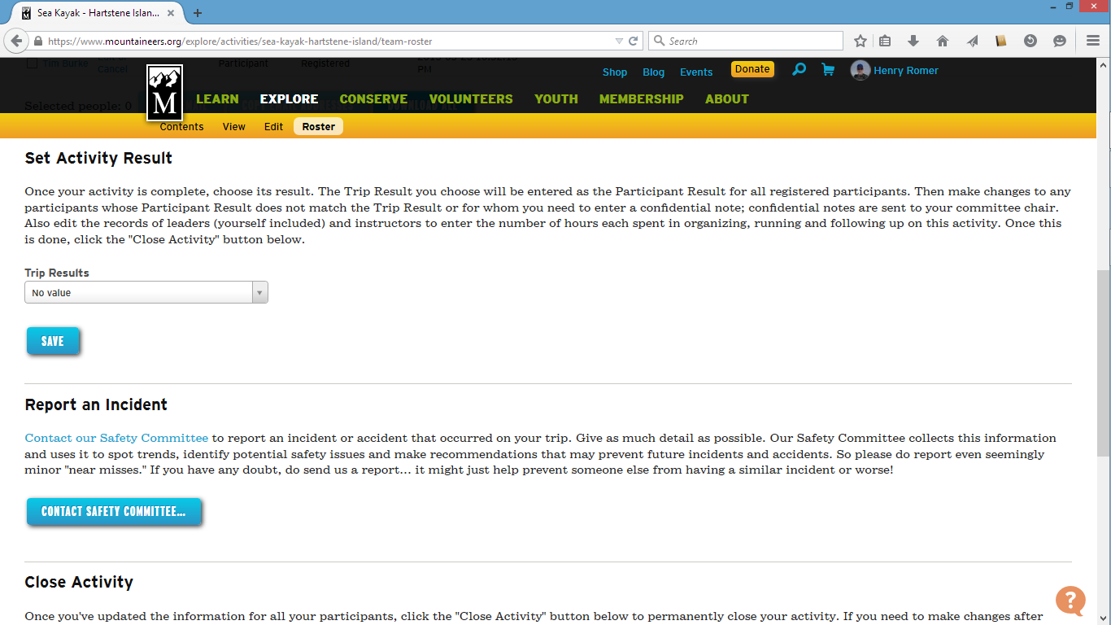

Select “Successful” for the group and then revise individual participants
if needed

Report any incidents here

Don’t forget to close the activity after the trip when the roster is finalized

